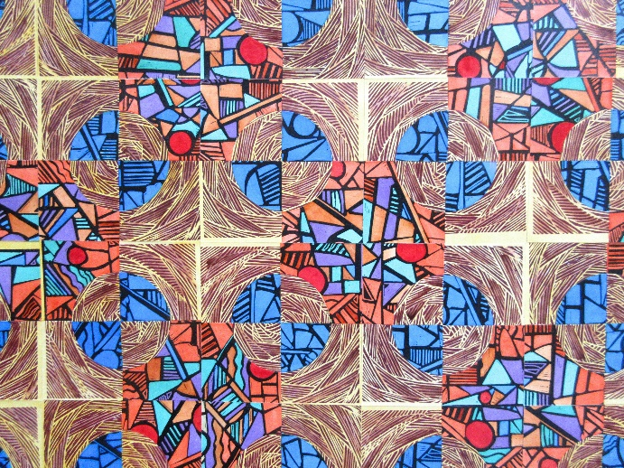
March 21, 2021 – May 23, 2021

From Brayer to Brush

Hand-colored woodcut collages

by

Jim Sherraden

#99, hand-colored woodcut collage

Jim Sherraden, a native of Salina, Kansas, has been a resident of Nashville, Tennessee since 1977. There he completed his university studies, which included a strong education in printmaking. From this foundation, he managed Hatch Show Print from in 1984 until 2013, overseeing the press’s transition from a cultural survivor to a widely recognized graphic design icon and destination for letterpress enthusiasts.

Through Hatch, his clients included Emmylou Harris, B.B. King, Neil Young, Bruce Springsteen, Fossil Watch Company, Entertainment Weekly, the city of Nashville, and uncountable others. In 1992, he began creating individual pieces of art called monoprints. These artworks are based on the Hatch archive and are collected by individuals and institutions worldwide, including the Ayers collection of Tennessee artists for First Bank in Nashville.

Sherraden has travelled extensively, both nationally and internationally, conducting workshops and as a speaker at graphic design conferences and universities such as Art Center Pasadena, Ringling School of Art in Sarasota, FL, Boston University, the School of Visual Arts, New York, and the Kansas City Art Institute. He has overseen and participated in multiple installations of Hatch Show Print, including the John F. Kennedy Center for the Performing Arts in 2006, a four year traveling exhibition with the Smithsonian Institution, and venues in the Netherlands, Norway, France, and England. Numerous publications have featured his work, most notably Steven Heller and Gail Anderson’s New Vintage Type, David Carson’s The End of Print, and Meggs History of Graphic Design, 5th edition. He is also the co-author of Hatch Show Print, the History of a Great American Poster Shop, now in its seventh printing, and is an award-winning lyric writer. Sherraden garnered the 2013 Distinguished Artist Award for the state of Tennessee, the American Advertising Federation Nashville chapters' Silver Medal (its highest honor), and is a recent recipient of the University and College Design Association’s Krider Prize for creativity.

In 2005, Sherraden returned to carving his own woodcuts, continuing the work that first led him to Hatch Show Print over 30 years earlier. Six years later he began creating wooden quilts and then paper quilts the subsequent year. For these works of art, the artist readily cuts up his own printed pieces, mixing and matching them on single and multi-dimensional surfaces. His quilts have recently been shown in 2016 at Yard Dog Gallery in Austin, Texas, Middle Tennessee State University’s Todd Art Gallery, and the AD 20/21 Boston Print Fair, as well as the 2017 exhibitions HATCH-ed at the historic Belcourt Theatre in Nashville and From Brayer to Brush at the Southern Studies Conference at Auburn University Montgomery.

Sherraden continues to serve Hatch Show Print as its “Master Printer Emeritus” while pursuing his own studio practice in White’s Creek, Tennessee.

Artist’s Statement:

There's three themes in the work.
1. Balance of Design Found in Nature. Think spider webs, butterfly wings, a magnolia bloom.
2. Individualization of utilitarian items. Think Native American rugs, Mediterranean tiles, African textiles.
3. Repurposing of objects from their originally intended use. Think Quilts, or Feed Bag Dresses.
I carve my own woodblocks and print them and then cut that paper, mixing and matching, into quilt/tile/textile-like patterns either traditional or those of my own design. Watercolor is applied after the final assembly.
My primary inspiration? That little ole letterpress shop in downtown Nashville where I proudly was employed for 34 years. Those tens of thousands of posters and designs created have led me to what you see on these walls. Also, all the "copy" i.e. information, on a Hatch poster, reading as a "continuous line"? Well, if you saw the frame that all the type is set in, and turned it around to look at the back, you'd see each letter and spacing is, in itself, a part of a larger pattern, which creates the poster in its entirety. Of course this has influenced my work today.

Birger Sandzén Memorial Gallery
401 N. First Street, PO Box 348, Lindsborg, KS 67456
(785) 227-2220 sandzengallery@gmail.com www.sandzen.org
Gallery Hours: Tuesday through Saturday from 10 a.m. to 5 p.m. and Sunday, 1 to 5 p.m.

