August 6 through October 23, 2016
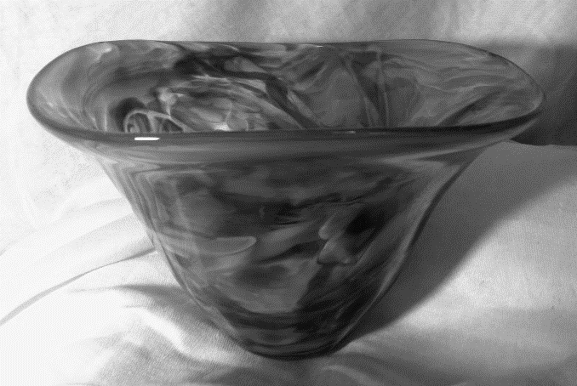
Celestia
blown glass by
Helen Koons Gragert of
Stillwater, Oklahoma

Statement
Merry Weather Skies by Helen Koons Gragert
Celestia has evolved over the last several years as a personal tribute from my heart to my loved ones, to those who have nurtured, encouraged, and inspired me. In my mind there was no better way to honor them and their significance in my life than through creations of blown glass.
Many of my glass pieces are of a musical nature because of the music so many members of my family have contributed to my life and well-being. In addition, the dance and flow of shapes and sizes within the groupings originated from dreamy memories and lasting impressions.
One piece, Eternity, is a richly filled palette of sparkling colors and a swirling strand of white. It expresses my deep gratitude to my husband for all of our years of love and life together and, I pray, many more to come. As with all of my endeavors, I could not have blown this large a piece without Steve’s assistance and support.
My choice of colors in some pieces—the use of twists of glass canes or fused inserts—often evoked endearing perceptions of loved ones. Merry Weather Skies reminds me of my dear grandmother. That piece on the hot blow pipe was like the reflection of a magnificent sunrise, the type of morning sky Mamo always told me the fairy godmother, Merryweather, had painted just for us.
Designing and experimenting with my concepts was a joyful process through the years. I have been privately and passionately fulfilled with the creation of this body of work, a work of love for those dearest to me. I am deeply indebted to the Birger Sandzén Memorial Gallery for this opportunity to show and share my work.

Biography
Very few women receive a set of blow pipes as an anniversary gift, but Helen Koons Gragert was given such a treasure by her husband, Steve, on the couple’s tenth. She was ecstatic.
Helen is a native of Lindsborg, Kansas, and credits the rich artistic environment of the community and schools for her vocation and avocation. Helen and her mother, Kathleen Koons, frequently visited the Birger Sandzén Memorial Gallery, and those memories have served to inspire and motivate Helen.
A glassblower for more than thirty years, Helen has operated and maintained a private studio, without assistance, for nearly nineteen of those years. Most glassblowers work with assistants, but Helen chose to immerse herself in her creative endeavors, as well as in the operation of her furnace, glory hole, and other glassblowing equipment. Although the arrangement proved frustrating and challenging at times, Helen took pride in her accomplishments, the reward of achieving the creations she envisioned.
When Helen blows glass, a day rarely passes that she does not exclaim to herself, “I can’t believe I am doing this!” She wishes others could see and feel the same excitement and passion she experiences when the glass is hot and full of glowing, sparkling colors dancing at the end of a blowpipe. She likens the molten glass to the center of the universe: stars pulsating, clusters of galaxies flowing. Even in its absolute frozen state, sitting on a table as a bowl or vase, glass radiates and reflects life around it, constantly catching light, always moving, relentlessly evolving.
Throughout her day, whether or not she is actually blowing, she continually arranges in her mind shapes and colors from nature. When she sees a finished piece of her glass, she does a double take and then realizes that it is her sitting there, a reflection of her inner being, of her own nature. Glass is her language of expression.
She hopes her work will touch you, the viewer, with the same sense of joy that she experienced in its creation.

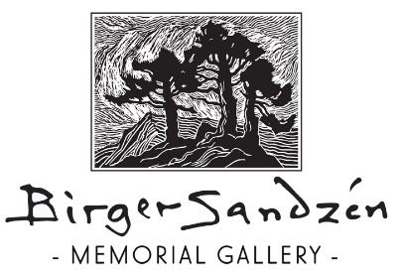
401 N. First Street, PO Box 348, Lindsborg, KS 67456
(785) 227-2220 fineart@sandzen.org www.sandzen.org
Gallery Hours: Tuesday through Saturday from 10 a.m. to 5 p.m. and Sunday, 1 to 5 p.m.

